**West Virginia Reading Association**

**WV AUTHORS FORM**

[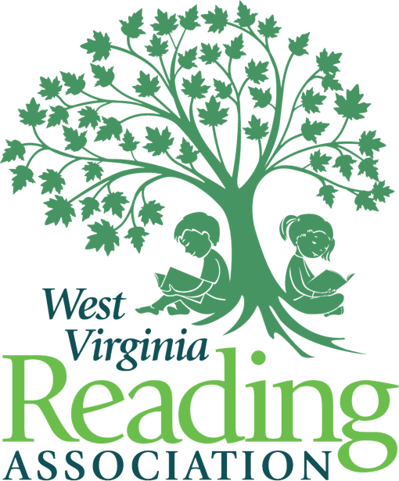](https://wvreading.com/)

Dear West Virginia Authors:

For more than 50 years, WVRA members have consistently demonstrated a strong commitment to encouraging and supporting all West Virginia readers. We remain confident, committed, and caring West Virginians who are dedicated to the importance of reading and literacy.

Our 68th annual conference will take place on November 21-22, 2024, at The Oglebay Resort in Wheeling, WV. This year, the conference will celebrate and embrace career readiness at all grade levels, creating lifelong learners. The conference theme is*“Yes, We Can!”* and reflects the amazing impact that literacy has Kindergarten through lifelong learning.

WVRA is delighted to invite WV Authors to attend the conference once again at a special reduced rate, of $50. This is a $60 discount off the regular preregistration fee. Please complete the online form located at: <https://forms.gle/eM646APz4456PuS38> (or return the copy below, electronic submission is preferred). We also hope to include expand opportunities for authors to engage with participants (to increase visibility and book sales. Details forthcoming!)

Payment must be made on or before October 18, 2024, in order to receive this reduced rate. Payment is to be made via this link: <https://square.link/u/R8DedJuO>

With this rate, authors will receive space at a table in the Author Interactive area. Lodging is the responsibility of the authors. While at the table, authors may sell and sign as many books as they wish. Please note that all materials should fit on a standard size table and should not interfere with other authors. Attendees enjoy visiting authors and purchasing autographed copies of their books during the conference. We hope that this will enable authors to network with conferees and other authors. WVRA looks forward to seeing you in November. Authors wishing to present concurrent sessions or workshops during the conference must complete and have accepted for presentation a proposal on the 2024 Call for Proposal form on the wvreading.com website and must pay to register as a WV Author.

**WV AUTHORS REGISTRATION FORM**

NAME: ____________________________________________________________________________

(As it is to appear in the conference program)

Mailing Address: ____________________________________________________________________

City: ________________________________State: ________ Zip Code: _______________

E-Mail Address: ___________________________

Preferred Telephone Number: (_____) ____________; I can receive texts at this number __ yes __ no.

Best times to contact me, only if necessary______________________________________.

______ Number of tables at $50 each. Enclosed is my payment of $_______ for the table(s).

## OR Online registration will be available for credit card payments at $50 per table at:

## <https://square.link/u/R8DedJuO>

Please indicate below, the times you plan to attend the conference. This will allow the conference committee to be sure there is enough tables for all the authors.

Thursday, November 21, 2024: _________________AM __________________ PM

Friday, November 22, 2024: _______________ AM ___________________ PM

**Please return this form by either mail or e-mail, on or before October 15, 2024:**

WVRA Author Registration, Dr. Stephanie Burdette  
4623 Country Club Blvd   
South Charleston, WV 25309

Stephanie.burdette@wvstateu.edu

**MERCHANDISE FORWARDING**  
Registered authors will be provided details for sending their merchandise to the resort,