August 22, 2023

Hello West Virginia educators,

I’m the Citations and Awards Chair of the West Virginia Reading Association. My job is to gather the names of educators who have done outstanding work in reading literacy and to recognize them in November at our annual conference at the Greenbrier. Then, hopefully, we can utilize their skills to teach other teachers!

I need your help. As educators we recognize outstanding work, and I need you to tell me who is doing it… even if it’s YOU!

I have two attachments to this email. The first one describes the three awards that are given for outstanding performance in reading literacy which is open to all educators in WV, not just WVRA members; the second attachment is the nomination form for each person you want to nominate.

It’s also my job to collect applications for a grant titled The Cynthia Lorentz-Cook Memorial Grant. It’s only open to teachers that work in counties that have a council in the WVRA. You must have a literacy program or project idea, and on the application, you must describe it. The grant money is a maximum of $500. Those applications are available from your county council president, or contact me, and I’ll send you one.

Unfortunately, I have to have all these nominations and project ideas sent to me by Friday, September 9. I know that’s not much time, but please get them to me ASAP.

Thanks so much,
Linda Childers
Citations and Awards Chair
artforthesoulwv@hotmail.com
304-633-2841

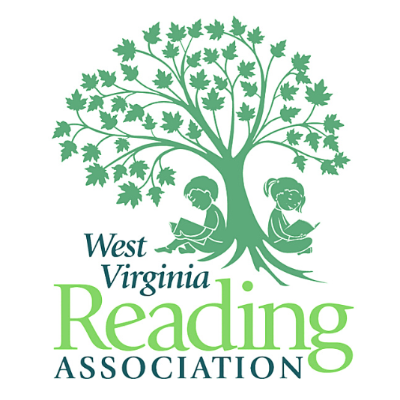
West Virginia Reading Association

Changing Lives Through Reading

