August 22, 2023

Hello Council Presidents,

As the Citations and Awards Chair of the West Virginia Reading Association, one of my jobs is to share information about a yearly grant of up to $500. This money is given through our WVRA and titled The Cynthia Lorentz-Cook Memorial Grant. It’s only open to teachers that work in counties that have a council in the WVRA. You must have a literacy program or project idea, and on the application, you must describe it. The recipient of that grant will be selected from those applicants turned in by Friday, September 9.

I’m attaching the application for the grant to this email. It is my hope that you will disseminate this information to your membership ASAP.

It’s also my job to collect applications for this grant; I have to have all these project ideas sent to me by Friday, September 9. I know that’s not much time, but please get them to me ASAP.

Thanks so much,
Linda Childers
Citations and Awards Chair
artforthesoulwv@hotmail.com
304-633-2841

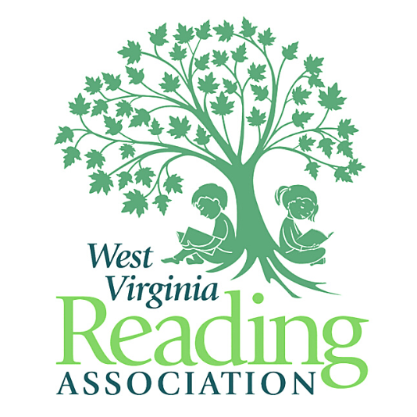
West Virginia Reading Association

Changing Lives Through Reading

