West Virginia Reading Association
WV AUTHORS FORM
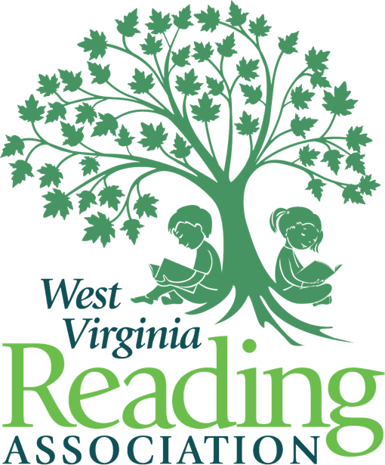

Dear West Virginia Authors:
In 1968, we started a reading (R)evolution as the first professional organization in our state dedicated to improving reading education. Then and now, WVRA members have consistently demonstrated a strong commitment to encouraging and supporting all West Virginia readers. More than 50 years later, we remain confident, committed, and caring West Virginians who are dedicated to the importance of reading and literacy.
We will hold our 67th annual conference on November 16 - 17, 2023, in White Sulphur Springs, WV at the beautiful Greenbrier Resort. This year, the conference will celebrate and embrace career readiness at all grade levels, creating lifelong learners. The conference theme is “Reading Opens Doors for the Future” and reflects the amazing impact that literacy has Kindergarten through lifelong learning.
WVRA is delighted to invite WV Authors to attend the conference once again at a special reduced rate, of $50. This is a $60 discount off the regular preregistration fee. Please complete and return this special registration form especially for WV authors along with full payment on or before October 16, 2023 in order to receive this reduced rate. With this rate, authors will receive space at a table in the Author Interactive area currently located in the Exhibit Hall. Lodging is the responsibility of the authors. A special rate is available from the Greenbrier. The form may be obtained at www.wvreading.com under Conference 2023. While at the table, authors may sell and sign as many books as they wish. Please note that all materials should fit on a standard size table and should not interfere with other authors. Attendees enjoy visiting with authors and purchasing autographed copies of their books during the conference. We hope that this will enable authors to network with conferees and other authors. WVRA looks forward to seeing you in November. Authors wishing to present concurrent sessions or workshops during the conference, must complete and have accepted for presentation a proposal on the 2023 Call for Proposal form on the wvreading.com website and must pay to register as a WV Author.

WV AUTHORS REGISTRATION FORM

NAME: ____________________________________________________________________________
(As it is to appear in the conference program)

Mailing Address: ____________________________________________________________________

City: ________________________________State: ________ Zip Code: _______________

E-Mail Address: ___________________________
Preferred Telephone Number: (_____) ____________; I can receive texts at this number __ yes __ no.

Best times to contact me, only if necessary______________________________________.

______ Number of tables at $50 each. Enclosed is my payment of $_______ for the table(s).

OR Online registration will be available for credit card payments at $50 per table at: www.wvreading.com or https://square.link/u/R8DedJuO

______ I would like to purchase a luncheon ticket for Thursday, November 16, 2023, for $45.
Enclosed is my payment of $______ for the luncheon ticket.
______ I would like to purchase a luncheon ticket for Friday, November 17, 2023, for $45.
Enclosed is my payment of $______ for the luncheon ticket.

Please indicate below, the times you plan to attend the conference. This will allow the conference committee to be sure there is enough tables for all the authors.
Thursday, November 16, 2023: _________________AM __________________ PM
Friday, November 17, 2023: _______________ AM ___________________ PM

Please return this form by either mail or e-mail, on or before October 16, 2023:
WVRA Author Registration, Anna Holst
1035 Norway Avenue
Huntington, WV 25705
aholst@k12.wv.us

MERCHANDISE FORWARDING
Books and other materials may be mailed previous to conference beginning to:
Guest Name & Company, WVRA Exhibits
The Greenbrier
Porter c/o Ally Eppling
WV Reading / VENDOR NAME
101 Main Street, West
White Sulphur Springs, WV 24986

