**Your county has been invited to hold school and county level Literature Fairs and send first place county winners to the WVRA District 5 Literature Fair on November 4th, 2017, at Glenville State College Mollohan Center.**

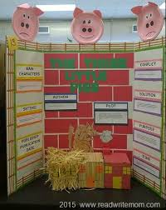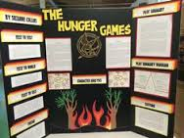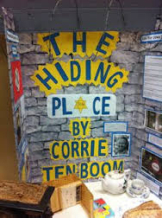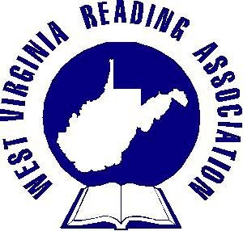

**For more information please contact:**

**Tila Boyce** [**tboyce@k12.wv.us**](mailto:tboyce@k12.wv.us)

**Tony Nichols** [**tonytown@frontier.com**](mailto:tonytown@frontier.com)

**Kathy Chapman** [**klchapman@frontiernet.net**](mailto:klchapman@frontiernet.net)

**Tammi Gregory tammilg@hotmail.com**

**Guidelines, divisions, categories and score sheets will be provided.**

WVRA District 5

Literature

Fair